# ES6 Objectives - Answers

## List the features of ES6

1. Arrow functions  
2. let and const keywords  
3. Template literals  
4. Default parameters  
5. Rest and spread operators  
6. Classes and inheritance  
7. Destructuring assignment  
8. Promises  
9. Modules (import/export)  
10. Enhanced object literals

## Explain JavaScript let

The `let` keyword declares block-scoped variables. Unlike `var`, it does not allow redeclaration in the same scope and is limited to the block where it is defined. This helps prevent problems with variable hoisting.

## Identify the differences between var and let

| Feature | var | let |
| --- | --- | --- |
| Scope | Function-scoped | Block-scoped |
| Redeclaration | Allowed | Not allowed in same scope |
| Hoisting | Hoisted and initialized | Hoisted but not initialized |

## Explain JavaScript const

The `const` keyword declares variables whose values cannot be reassigned. It is block-scoped like `let` and must be initialized when declared. Objects declared with `const` can still have their properties changed.

## Explain ES6 class fundamentals

ES6 introduced a new syntax for creating classes with the `class` keyword. It supports constructors, methods, and inheritance. Classes in ES6 are a simpler way to use JavaScript’s existing prototype-based inheritance.

## Explain ES6 class inheritance

Inheritance in ES6 classes uses the `extends` keyword. The child class can call the parent class constructor with `super()`. This allows the child class to inherit properties and methods from the parent class.

## Define ES6 arrow functions

Arrow functions offer a shorter way to write functions. They do not have their own `this` context, which helps in cases where you want to keep the `this` from the parent scope.  
Example: const add = (a, b) => a + b;

## Identify set(), map()

- `Set`: A collection of unique values. Duplicates are removed automatically.  
 Example: const mySet = new Set([1, 2, 2, 3]); // {1, 2, 3}  
- `Map`: A collection of key-value pairs with keys of any data type.  
 Example: const myMap = new Map(); myMap.set('a', 1);

**OUTPUT:-**

**When Flag=true**

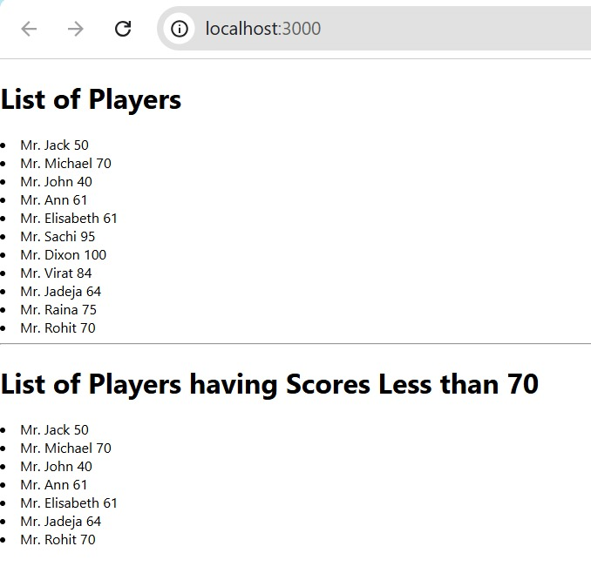

**When Flag=false**

